LONDON
VAGINA WARRIOR WORKSHOP

Sunday, October 12, 2008

-----------------------------------------------------------------------------------------
DETAILS:

Venue: Dragon Hall, 17 Stukeley Street, in Holborn, London. (www.dragonhall.org.uk)

Time: 9AM to 11AM – pre workshop gathering with V-Day staff to discuss any administrative, tech or other concerns you may have. This is a great opportunity to have any of your logistical producing questions answered by staff as well as other organizers that will have their experiences to offer.

11AM to 3PM – Workshop with Eve.

3PM to 4PM – We will be showing a screening of “What I Want My Words To Do To You” to introduce everyone to this new event piece.

Food: A light breakfast will be available during the morning session and we will be providing lunch around 1PM.

Dress: The atmosphere is relaxed - wear casual, comfortable clothes.
SUGGESTED ACCOMMODATIONS:
London can be an expensive place to visit, and many hotels close to our *very central* workshop venue are highly priced. Below are some hostels and reasonably-priced hotels, all within walking distance to the workshop. Most rates include breakfast.

(You are certainly welcome to find your own accommodations if you wish - www.hostelbookers.com is helpful. Of course, there’s always Expedia www.expedia.co.uk or Last Minute www.lastminute.co.uk. Neighbourhoods within walking distance of the workshop are Holborn, Soho, Bloomsbury (or Russell Square), and Clerkenwell; surrounding postcodes are W1, WC1 and EC1. )

Ashlee House: Dorm beds from £9/night (don’t forget a picture ID)
www.ashleehouse.co.uk
261-265 Grays Inn Road, London WC1X 8QT,
Tel: +44 (0)20 7833 9400
Email: group@ashleehouse.co.uk

Generator Hostel: Dorm beds from £17.50/night (don’t forget a picture ID)
www.generatorhostels.com/london/
Compton Place (Off 37 Tavistock Place) London WC1H 9SE
Tel: +44 (0)20 7388 7666
Email: London@Generatorhostels.com

Guilford Hotel: Double rooms from £69/night
www.guilford.fsbusiness.co.uk
6 Guilford Street, London WC1 1DR
Tel: +44 (0)207 430 2504
Email: guilford-hotel@lineone.net

Travelodge: Double rooms from £85/night
Locations within walking distance of the workshop in King’s Cross, Euston and Covent Garden, book online at www.travelodge.co.uk

Grange Hotels: We have arranged a preferred rate with the Grange Hotel group, who manage a number of four-star hotels in the Holborn area. A rate of £120 - £140/night for a double room is available for 11th and 12th October. Indicate that you are participating in the V-Day workshop to receive this rate (subject to availability). The Grange City and Grange Holborn Hotels are the closest to the venue, but all are very nearby.
Tel: +44 (0)845 450 9900
Email: reservations@grangehotels.com
(Any problems with receiving the preferred rate, contact Amanda Blanchard, +44 (0)207 630 2000
amanda.blanchard@grangehotels.com – weekdays only)
See PDF form they provided for reservations

If you are travelling alone and would like to connect with other V-Day organizers to help share the cost of travel, please visit the V-Spot VWW forum to post and connect.
**This will be available when you are approved and on the Vspot.**

TRANSPORTATION:
Public transportation in London is fantastic. For maps, journey planning and directions (for any form of transportation at all, www.tfl.gov.uk is your primary resource. Tickets for travel by bus and underground can be purchased in any London underground station and in many newsagent shops. See www.tfl.gov.uk/tickets/faresandtickets for types of tickets and where to buy. Special fares are available for overseas visitors.

Black cabs are generally slightly more expensive than car services for long distances – however they are widely available, can be flagged on the street and are affordable for short distances without traffic. Our recommended car service is Addison Lee; book online at www.addisonlee.com or on 0207 387 8888.

Airports: Heathrow, Gatwick, Luton, Stansted, and London City airports are all accessible by National Rail or London Underground. Transport information to and from airports can be found at http://www.visitlondon.com/travel/airport

Trains: nearest National Rail (overland) stations are Euston, King’s Cross St Pancras and Charing Cross. To plan your journey by overland train, please see www.nationalrail.co.uk

Bus: Holborn is well serviced by local buses; to view these routes please see www.tfl.gov.uk

Please note: If you plan to use a car service from an airport, call ahead to verify schedules, reservations and fares. Do not, under any circumstances, take an unauthorised minicab or a taxi offered by someone standing in the street or walking around the station/airport.

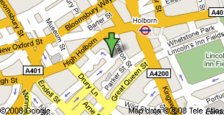
The Dragon Hall is located at 17 Stukeley Street, London, WC2B 5LT
Nearest tube: Holborn (Central and Piccadilly lines)
Nearest rail: Charing Cross

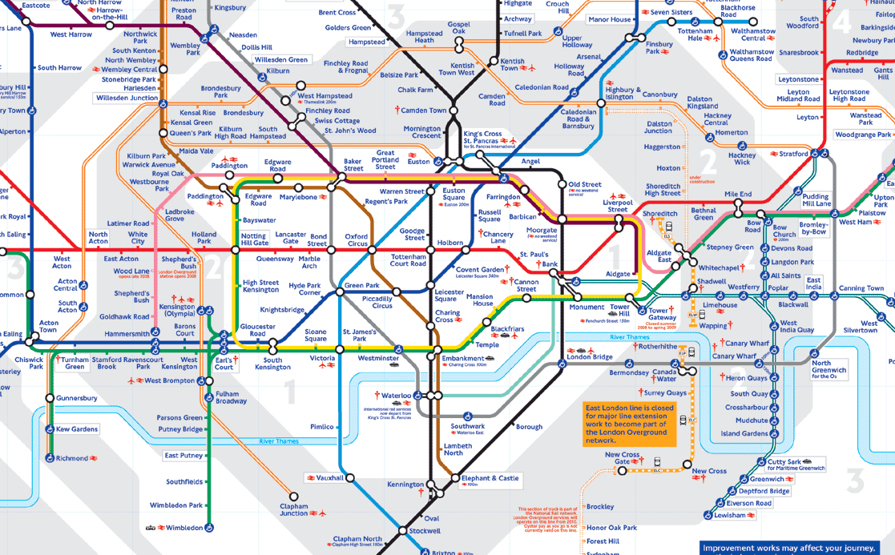

ONE OTHER NOTE:

The London Feminist Network is having an event on 11th October, if you’d like to attend. http://www.fil.btik.com/home.ikml.

PROBLEMS or QUESTIONS:
Please bring Shael’s cell phone number (917) 449-8708) with you in you need anything when you get there. Annie Saunders and Emma Jane Richards, who are hosting the Workshop in London, can be reached at +44 (0)7789 915 818 or +44 (0)7515 346 426, or at anniesaunders@gmail.com and richards.emmajane@gmail.com.

